Dataset Understanding — World Happiness Report 2016
Dataset Overview
- Total observations (countries): 157
- Total variables: 13
Variable Types
- Character (string):
  - Country
  - Region
- Integer:
  - Happiness.Rank
- Numeric:
  - Happiness.Score
  - Lower.Confidence.Interval
  - Upper.Confidence.Interval
  - Economy..GDP.per.Capita.
  - Family
  - Health..Life.Expectancy.
  - Freedom
  - Trust..Government.Corruption.
  - Generosity
  - Dystopia.Residual
Interpretation for Report
The dataset consists of quantitative measures that contribute to global happiness rankings across 157 countries. Most variables are continuous numeric values, while country identifiers and regional classifications are stored as character strings. This structure is appropriate for statistical modelling and correlation-based analysis.

Visualisation & Analysis (Step 3 & Step 4)
Visualisation
Scatterplot of Happiness Score vs Economy (GDP per Capita)
A scatterplot was produced to visually examine the relationship between Happiness Score and Economy (GDP per Capita). Each point represents a country, with a fitted linear regression line illustrating the overall trend.
The plot shows a clear positive linear trend, where countries with higher GDP per capita generally report higher happiness scores. The clustering of points along the regression line indicates a consistent relationship across different regions and economic levels. Only a few mild outliers appear, but none are influential enough to distort the overall pattern.
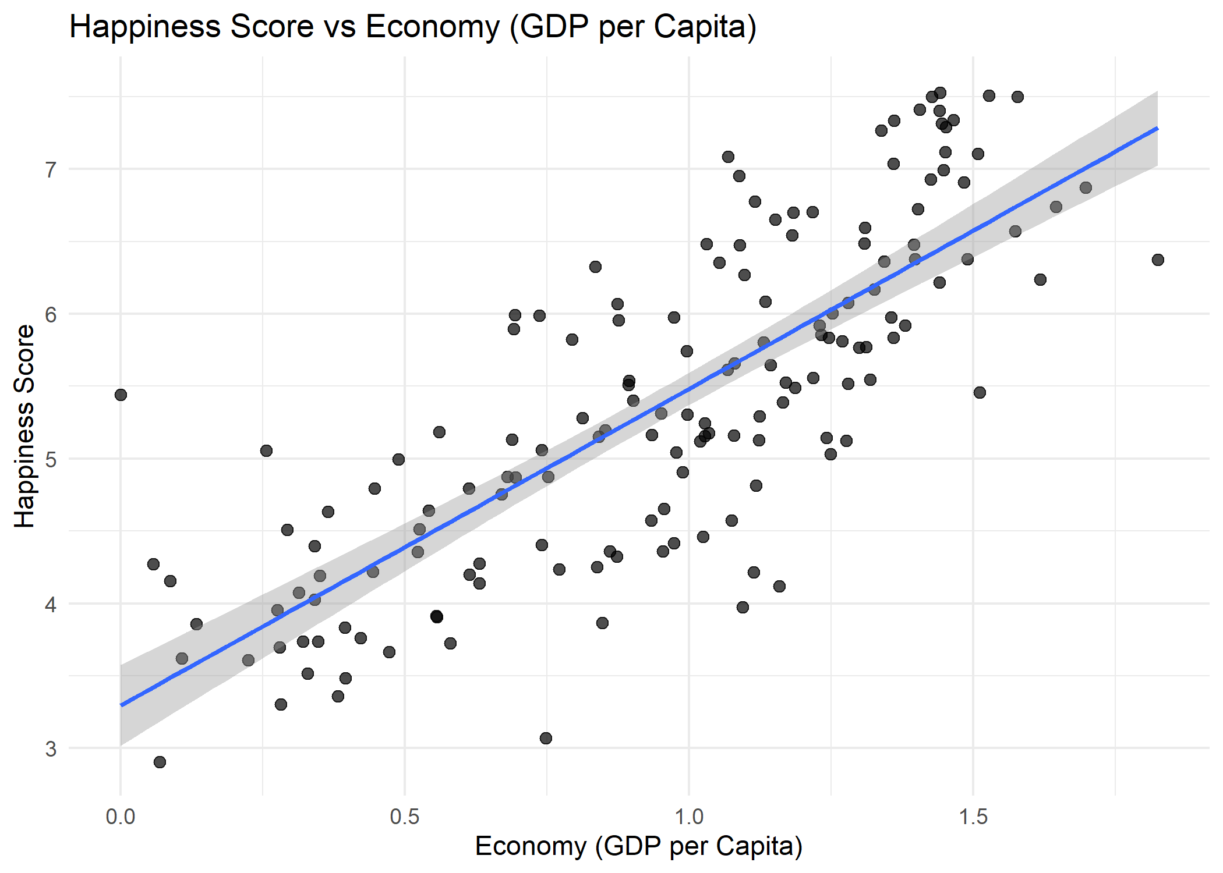
Figure: “stepA_scatter.png”
Additional Information for Data Understanding (optional but useful)
The scatterplot suggests that:
- The relationship is approximately linear, supporting the use of correlation and linear regression.
- Variability in Happiness Score decreases slightly at higher GDP values, indicating greater consistency among wealthier nations.
- No extreme outliers were identified that would violate basic regression assumptions.

Useful Information for Data Understanding
This visualisation reinforces that GDP per capita is likely a meaningful predictor of national happiness, warranting further statistical testing to quantify the strength and significance of this relationship.

Analysis
Statistical Tests Used
To formally test the hypothesis, two standard procedures were applied:
- Pearson Correlation Test
  - Measures the strength and direction of the linear relationship between the two variables.
- Simple Linear Regression
  - Quantifies how much Happiness Score changes on average for each unit increase in GDP per capita.
Results and Interpretation
Pearson Correlation
- Correlation coefficient (r): 0.790
- p-value: < 2.2e-16
- 95% CI: [0.723, 0.843]
Interpretation:
There is a strong, positive, and statistically significant correlation between GDP per capita and Happiness Score. The very small p-value suggests that the observed relationship is extremely unlikely to occur by chance.
Linear Regression
- Intercept: 3.296
- Slope: 2.187
- R²: 0.6246
- p-value (slope): < 2.2e-16
Interpretation:
The regression model indicates that for every 1-unit increase in GDP per capita, Happiness Score increases by approximately 2.19 units, on average.
An R² value of 0.6246 means GDP per capita explains about 62.5% of the variation in national happiness — a substantial effect size.
Null Hypothesis Decision
- Null hypothesis (H₀): There is no correlation between Happiness Score and Economy (GDP per Capita).
- Result: Rejected
- Reason: The p-values from both the correlation and regression analyses are far below 0.05, and the effect size is large.
Conclusion
There is strong statistical evidence of a positive and meaningful relationship between GDP per capita and national happiness. Countries with higher economic output per person tend to have significantly higher happiness scores.
INTERPRETATION OF HISTOGRAMS
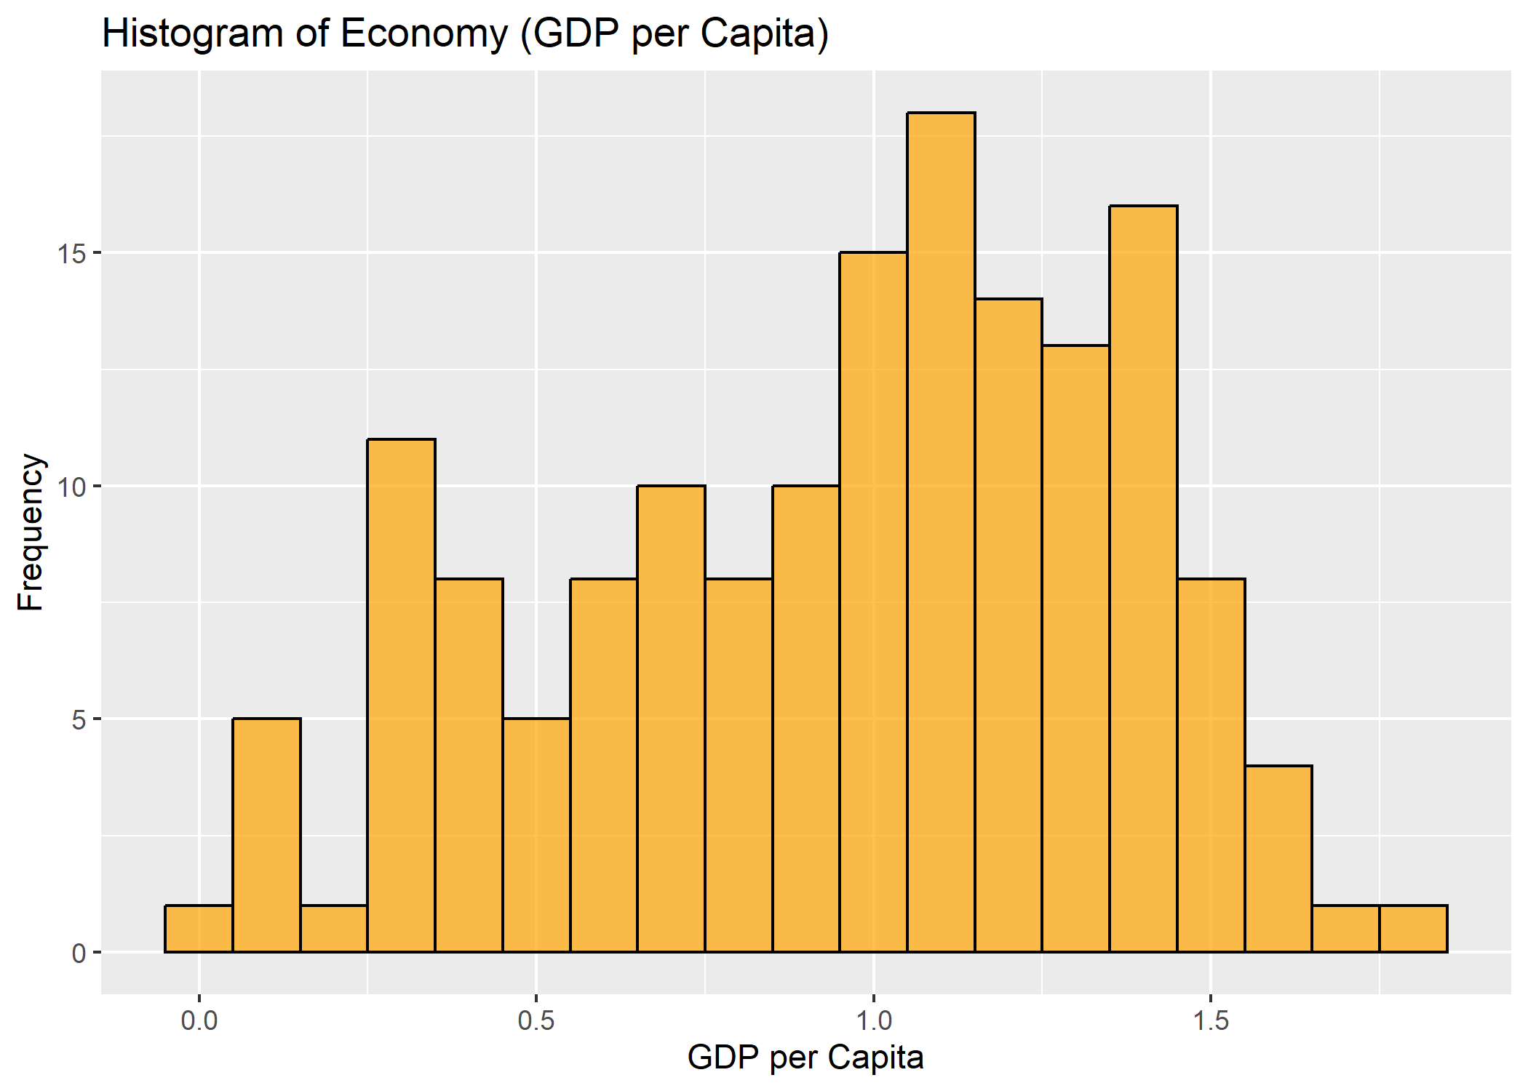 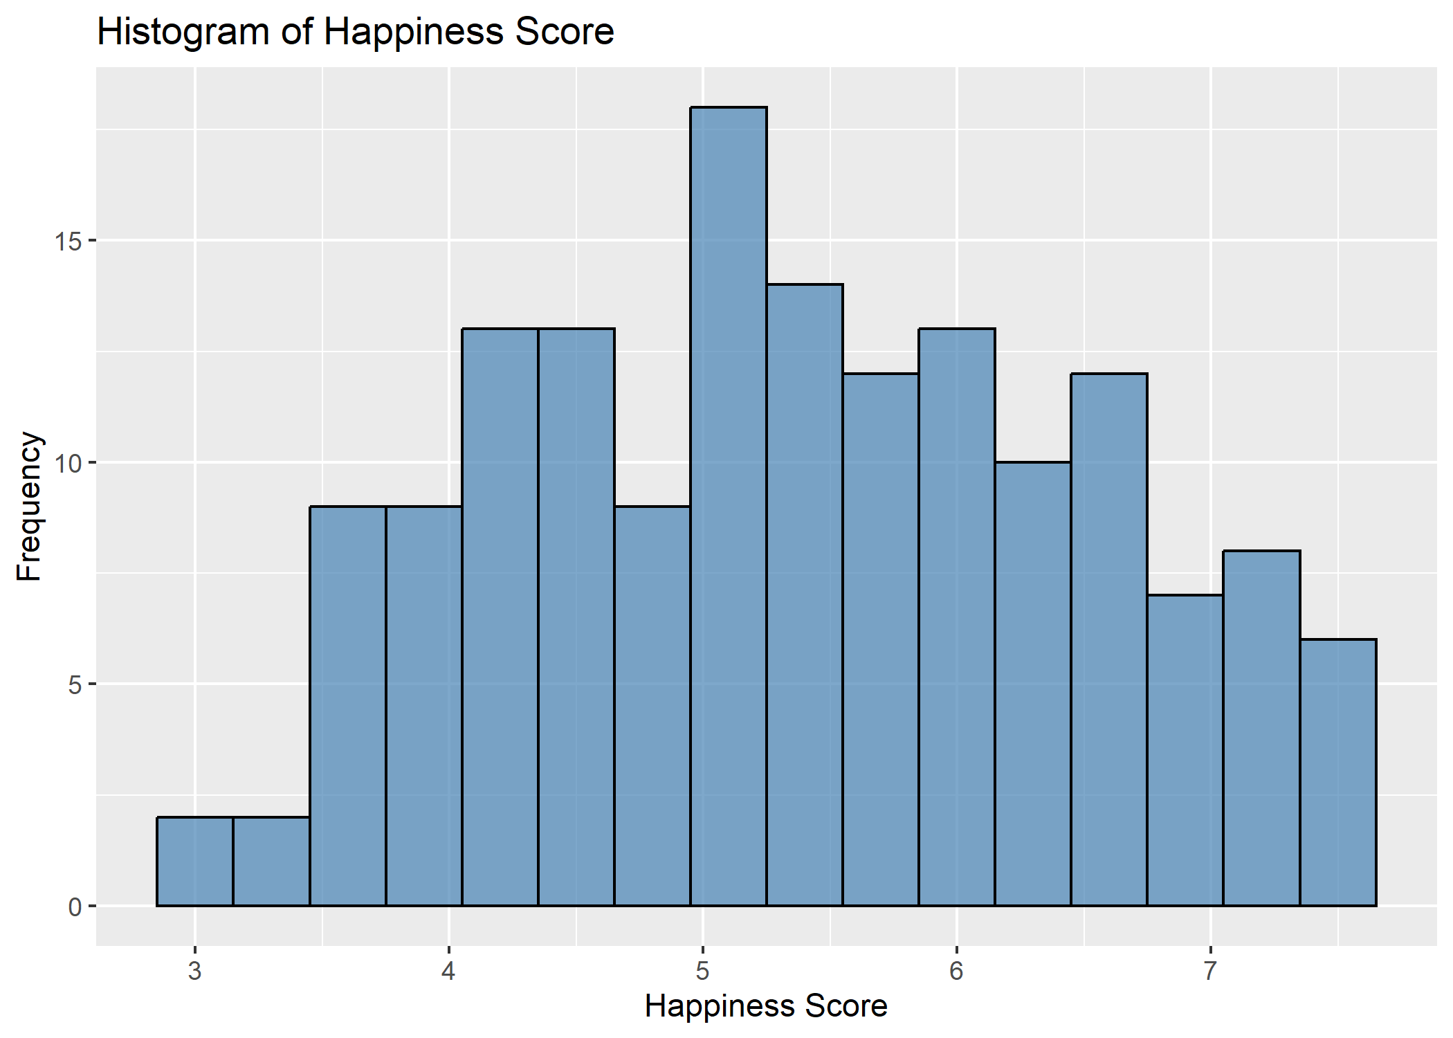

Histogram: Happiness Score
What we see:
- Distribution is roughly symmetric, slightly right skewed.
- Most countries score between 4 and 7.
- Very few countries have scores below 3.5 or above 7.5.
- No major outliers.
What this means:
- Happiness Score behaves like a continuous, reasonably normal variable.
- This supports using Pearson correlation (which we already computed).

Histogram: Economy (GDP per Capita)
What we see:
- The distribution is right-skewed.
- Many countries cluster between 0.7 and 1.3.
- A few poorer countries appear near 0.
- A few richer countries are above 1.5.
What this means:
- GDP values are more skewed than happiness.
- But scatterplot already shows a strong linear trend, and Pearson correlation is acceptable with this sample size (n=157).
Conclusion:
Histograms confirm that correlation is an appropriate method because:
- Both variables are continuous
- No extreme outliers
- Relationship appears linear

Useful Information for Data Understanding
Summary statistics: Happiness Score
- Minimum: 2.91
- 1st Quartile (Q1): 4.40
- Median: 5.31
- Mean: 5.38
- 3rd Quartile (Q3): 6.27
- Maximum: 7.53
- Standard Deviation: 1.14
These values indicate that happiness scores are moderately spread out but generally cluster between 4 and 7. The distribution suggests that while a few countries report very low happiness, most fall around the middle-to-high range. The SD of 1.14 shows moderate variation across countries.

Summary statistics: GDP per Capita (Economy)
- Minimum: 0.00
- 1st Quartile (Q1): 0.67
- Median: 1.03
- Mean: 0.95
- 3rd Quartile (Q3): 1.28
- Maximum: 1.82
- Standard Deviation: 0.41
GDP per capita values range widely, indicating considerable economic disparity between countries. The SD of 0.41 shows notable variation, with some countries having very low economic performance while others have high values near 1.8.

Correlation Between Variables
- Pearson correlation: 0.79
This is a strong positive linear relationship.
It suggests countries with higher GDP per capita tend to have higher happiness scores.
This correlation aligns strongly with the scatter plot and supports the alternative hypothesis (H₁) that a relationship exists.

